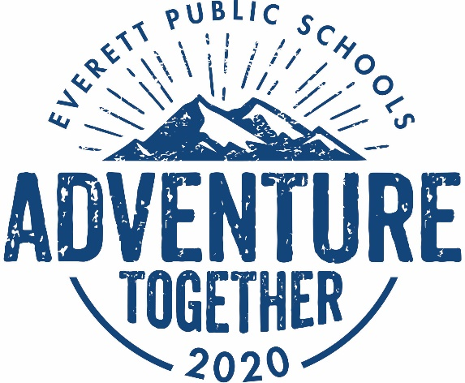August 19, 2020

Dear Everett Public Schools families:

We hope you are having a memorable summer and gearing up for a great school year. We know you have had many questions since we announced we would be opening school in the fall in a [fully remote model](https://docushare.everett.k12.wa.us/docushare/dsweb/Get/Document-113133/2020.07.29%20family%20communication%20on%20fall%20opening.pdf).

Because this year is starting out in a new way, we chose “Adventure Together” as a theme. This year will look and feel much different and will be a new, exciting and challenging “Adventure” for students, teachers and families. And, “Together” because we are all in this together. Although this start to school will feel different to everyone, we encourage taking on this challenge with courage, knowing we will all learn and grow as we navigate unfamiliar and unexpected situations. We are here for every student, every family, every teacher and every staff member. We are a team! Let’s Adventure Together!

We heard your feedback clearly and have made adjustments and improvements to the remote learning model since the spring. Below you will find more details and when your student may be able to shift to a hybrid model.

**What does a school day look like?**

Daily school schedules for grades K – 12 are now available on [the website](https://www.everettsd.org/Page/37563). There are two different elementary school schedules (based on whether your school typically starts early at 8:35 a.m., or later at 9:15 a.m.), a middle school schedule and a high school schedule. All schedules have time reserved for real-time instruction, guided independent work, lunch, and breaks between classes. All schedules also have the Learning Improvement Friday (LIF) when students are dismissed 75 minutes early, as in previous years. Schedules are posted to the website as viewable and printable documents and will be posted in multiple languages in the next several days.

**Will the teacher be taking attendance?**

We look forward to teaching your child every day. Regular attendance is important, and we will work with you to ensure your child is engaged in learning. For elementary students, attendance will be taken daily and recorded in Gradebook. Middle and high school students will have attendance taken each period. If your child will miss remote learning, please email the school at their attendance email address, which you can find on the school website.

**How will grading be handled?**

Grading will be done with the goal of providing feedback to students on their progress towards essential standards. For elementary students this will be via the score 1 to 4, as in the past. Middle and high school students will be graded A – F. All grades will be recorded in the online gradebook.

**Can there be one place to access all class information?**

Your feedback from remote learning in the spring was consistent: parents communicated the importance of access and ease-of-navigation for student learning experiences. You asked for a robust, centralized system that houses all key classroom information as well as a single location where the core applications are linked. This year we will be using Canvas as the district K-12 learning platform, which is accessible to parents and serves as a home base where directions for assignments, discussions and key resources will live. Your child’s teacher will have all of their content linked through Canvas.

**What about students who need special services?**

Special Services is following the same phased learning models as the district. Next week there will be FAQ on the special services web page with more information about how students with special needs will be supported in remote learning.

**Are you still providing meals?**

Yes, we will be providing meals at 13 school sites, and will be requesting you preorder. If you have completed the [free and reduced meal application](https://www.everettsd.org/Page/4830) you can pick up breakfast and lunch at your free or reduced rate. Meals will also be provided for purchase.

**How are you supporting parents?**

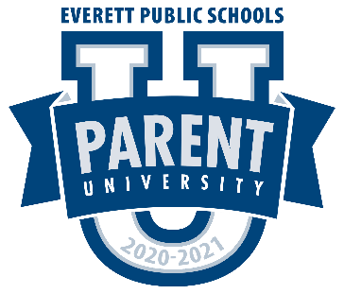Starting September 2, Everett Public Schools will have a Parent University available 24/7 online and mobile, for you to access important resources to help support your student’s remote learning. You can find details on how to access and log in to Canvas, how to view your student’s schedule, where to get meals, and much more. Resources will continue to be added throughout the year. You will find Parent University, and all other information related to remote learning, including which learning model we are in, at [www.everettsd.org/COVID2020-21](http://www.everettsd.org/COVID2020-21)

**What is social-emotional learning (SEL) and why is it in the schedule?**

We believe supporting Social and Emotional Learning for all students and adults is critical for student success and we have made SEL a key element in our learning framework. You can visit our [Student Support Services](https://www.everettsd.org/Page/36392) web page for more information on SEL.

**What if I need a Chromebook or hotspot for my child?**

There will be Chromebooks and hotspot distributions from your child’s school, so stay tuned for communication from your principal. This fall you can have one device for each student.

**How long will we be in remote learning?**

The Washington State Department of Health has provided a [Decision Tree](https://www.doh.wa.gov/Portals/1/Documents/1600/coronavirus/DecisionTree-K12schools.pdf) that helps guide the reopening of schools based on the level of community transmission of COVID-19. We are partnering with the Snohomish Health Department to stay up to date on the COVID-19 trends to help information our decision. We will give families several weeks’ notice before changing the learning model, and commit to updating you by November 1 if nothing has changed by then.

**Will there be athletics and after school activities?**

There will be no fall athletics and subsequent seasons are yet to be determined. Clubs can be held virtually, as communicated by individual advisors.

If you have a question that was not answered here, you can always talk to your principal. Also, there are Frequently Asked Questions and the opportunity to submit a question on our [COVID 2020-21](https://www.everettsd.org/Page/36795) web page.

I am looking forward to a great kick off to school this fall as we Adventure Together and I am grateful for your partnership. Thank you and be well.

Dr. Ian Saltzman

Superintendent

Everett Public Schools